# OpenAI API message roles

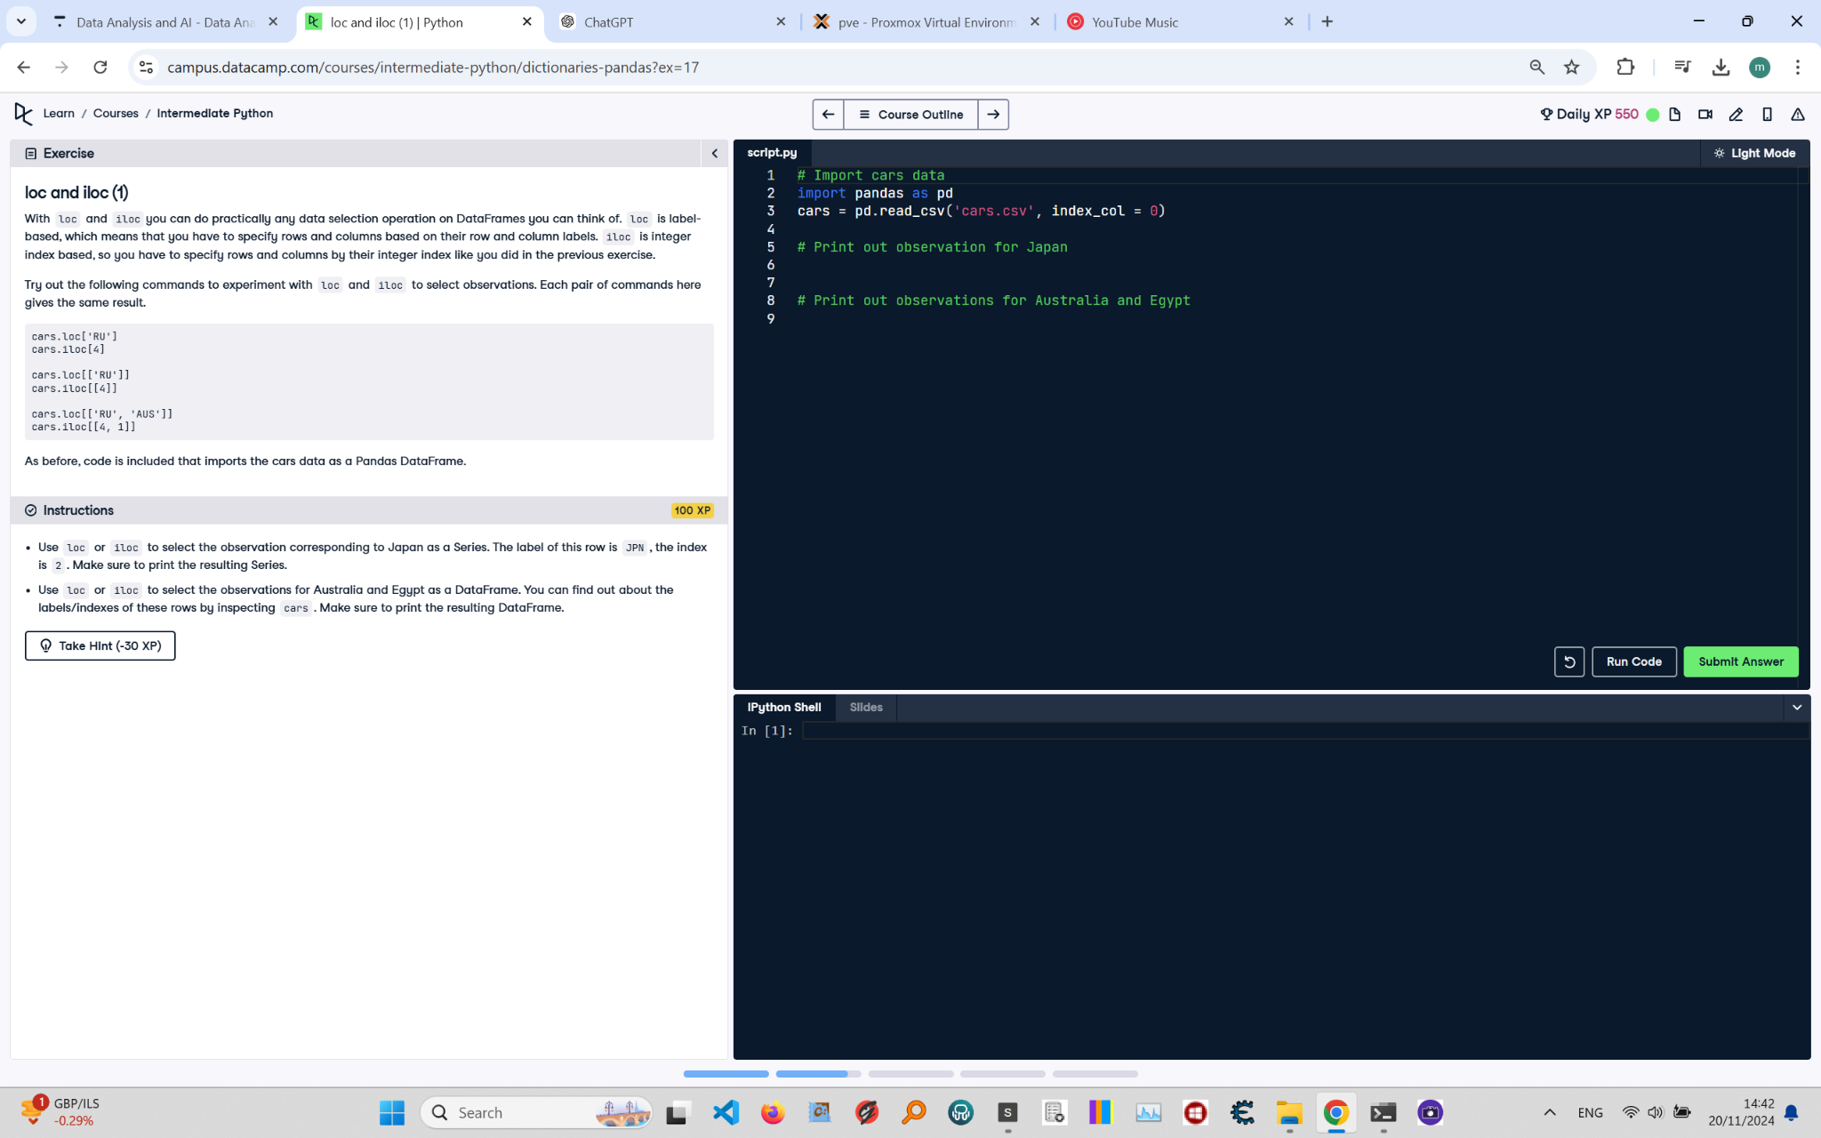

## Question

What is the issue with using OPENAI_API_TOKEN as the API key and how to fix it? Also, explain the correct use of roles in the messages.

## Question Explanation

The code initializes a chatbot using OpenAI API, requiring proper role definitions in the conversation messages and a correctly formatted API key placeholder. The assistant’s message is left blank to be filled by the model's output.

## Answer

# Create the OpenAI client: you can leave "<OPENAI_API_TOKEN>" as is  
client = OpenAI(api_key="<OPENAI_API_TOKEN>")  
  
# Define the conversation messages  
conversation_messages = [  
 {"role": "system", "content": "You are a helpful event management assistant."},  
 {"role": "user", "content": "What are some good conversation starters at networking events?"},  
 {"role": "assistant", "content": ""}  
]  
  
response = client.chat.completions.create(  
 model="gpt-4o-mini",  
 messages=conversation_messages  
)  
print(response.choices[0].message.content)

## Answer Explanation

This version of the script keeps the API key as a placeholder '<OPENAI_API_TOKEN>'. It defines three roles: 'system' sets the assistant's context, 'user' gives the input prompt, and 'assistant' is blank to be completed by the model. The response from the assistant is printed using the content returned from the API.